Personalized Vocabulary Reactivation in Real-Time AI Conversations

A Capstone Project Report of MSIT 5910

Submitted by:

[Ryotaro Fujiwara]

For the partial fulfilment of the requirements for the degree of
Master of Science in Information Technology

Supervised by:
[Dr. Sirisha]

Department of CS & MSIT
University of the People, Pasadena, CA 91101, United States
October 17, 2026

Abstract

Vocabulary that learners look up but never use in conversation is quickly forgotten, following the forgetting curve. Existing language-learning applications apply spaced repetition mainly to static exercises such as flashcards and drills, and few feed vocabulary use in free conversation back into a retention model. This project presents Mingo, a real-time AI conversation system that reactivates a learner’s own saved vocabulary during speaking practice. Learners save unfamiliar words, idioms, and syntax patterns as memos. When the AI asks a question, Mingo retrieves semantically relevant memo items by embedding-based retrieval-augmented generation (RAG) and ranks them using a Half-Life Regression (HLR) model so that items with lower estimated recall probability appear first. An LLM then combines the top-ranked items into an example sentence usable in the current conversation. Each interaction is recorded as a success with a hint, a success without a hint, or a failure, and it updates the item’s half-life. Items used successfully five times without a hint, with an estimated half-life of 180 days or more, are treated as mastered. The system also provides grammar correction and phoneme-level pronunciation feedback.

Because most standard RAGAS metrics assume fact-based text retrieval, three metrics suited to this task were used instead: expression_usage_rate, naturalness_score, and answer_relevancy. Reducing the number of retrieved expressions from five to four raised answer_relevancy from 0.4921 to 0.6922, improved naturalness_score from 9.4 to 9.6, and kept expression_usage_rate at 1.0. An integration test confirmed that memo data is isolated between users. Remaining limitations include dependence on memo content and repetitive conversation patterns. Future work includes improving hint relevance to the preceding conversation and handling the Gemini Live 15-minute session limit.

Acknowledgements
I would like to express my gratitude to Dr. Sirisha for her advice on the evaluation methods used in this project.

List of Figures

Figure 1 Half-life regression formula
Figure 2 Mastery (recall probability) formula
Figure 3 System dialog (overall conversation flow)
Figure 4 Comparison of metrics before and after adjustment
Figure 5 Test result of the data isolation integration test

Introduction
In language learning, the biggest concern is that if you leave the language you looked up unused, you quickly forget it. This is called "massed practice." If those expressions are not used or reviewed, memory decays exponentially over time following the "forgetting curve," and eventually you can no longer recall them. (Settles & Meeder, 2016)
For example, according to Ebbinghaus's model of memory, when the time since the last practice becomes long relative to the "half-life"—how long the word stays in memory—the probability of correctly recalling the word drops to almost zero.
In contrast, spaced repetition—using the word repeatedly at intervals—can extend the half-life in long-term memory and make the memory stick.
However, while current language-learning apps (such as Duolingo) let you review words and expressions in formal lessons like translation exercises, few track word use in free conversation and feed it back into a spaced-repetition algorithm.
Moreover, for memory retention, free conversation and interaction with conversational AI act as powerful retrieval practice, because learners must recall specific words and expressions on their own in context. (Dongliang Ding1,2 & Ahmad Muhyiddin B Yusof, 2025)
Other research has also shown that, compared with a group that simply relearned, a group that combined retrieval practice with spaced learning showed about twice the improvement in vocabulary acquisition and retention. (Nur Basak Karatas, 2025)
From the above, actively using unfamiliar vocabulary and expressions in free conversation with AI is essential for improving speaking. However, many existing AI conversation bots tend to stop at role-play based on preset scenarios or question-and-answer on general topics. They have not reached the level of dynamically reactivating, within the context of conversation, the learner's own vocabulary—words the learner looked up and took in once but still cannot retrieve when speaking—to encourage spontaneous language use. (Theme 4, Dongliang Ding1,2 & Ahmad Muhyiddin B Yusof, 2025)

In addition, existing spaced-repetition models and word-retention prediction algorithms have mainly been applied to isolated "static learning" such as drills, flashcards, and fill-in-the-blank exercises. (2.2 Spaced Repetition and Practice, Settles & Meeder, 2016)

A technical approach that seamlessly combines these vocabulary-retention systems with the context of actual real-time conversation—matching, via RAG, the memorized expressions that best fit the AI's dynamic conversation and offering them as "answer hints" in real time—has not yet been sufficiently explored. In other words, with conventional apps it is difficult to look up such vocabulary on the spot. In this study, we design and implement Mingo, a system that retrieves the learner's own memos by semantic search (embedding), ranks them by mastery and spaced repetition, and presents them on the spot during conversation, and we evaluate its effectiveness.

The overall flow of the system implemented here is as follows. First, on the screen, the user decides the AI's role and the situation by text input, and chooses the learning language, the explanation language, and the expected conversation speed with buttons. Once the input is confirmed, the user turns the microphone ON. From then on, the user can speak to the AI at any time, and interruptions are detected and handled automatically. The user's speech is first transcribed on the screen; an LLM then judges whether the utterance is grammatically correct, and if not, it replies in natural language with a corrected sentence and an explanation of why that sentence is appropriate.

If it is correct, the user's speech is analyzed at the phoneme level, and the results are analyzed by an LLM, which replies—again in natural language—with how the user should improve their pronunciation and linking. Whether or not there are corrections, the AI responds to the user's answer and asks a follow-up question. This is also transcribed. In the future, we would like to be able to add a replay feature for the AI's replies and hints, translation from the native language into the learning language, a search feature that visually displays grammar, words, and idioms (with colors and arrows) when the user enters text in the learning language, and a feature that presents memorized expressions as hints and visualizes the user's level of mastery.

Literature Review
The paper that influenced this project, Settles and Meeder (2016), A Trainable Spaced Repetition Model for Language Learning, proposes a novel model called Half-Life Regression (HLR), which uses machine learning to optimize spaced repetition schedules for foreign language learning. The study evaluated the model's effectiveness using real-world data from the language-learning application Duolingo and through deployment in a production environment.
First, cognitive psychology has established that spacing out learning sessions rather than cramming, and gradually increasing the intervals between sessions, improves long-term memory retention (Introduction, Settles & Meeder, 2016).
However, conventional spaced repetition algorithms relied on manually tuned fixed rules and parameters, making it difficult to adapt flexibly to differences in learners' proficiency levels and the difficulty of individual words. To address this limitation, the authors developed HLR, a model that estimates the half-life of a memory from a feature vector based on Ebbinghaus's forgetting curve theory.
The model was evaluated over six weeks with approximately one million users. The results showed a slight increase in overall learning activity and new lessons, while the number of review sessions decreased by 7.3%. The authors interpreted this reduction as evidence that, under the conventional approach, learners were sometimes required to complete unnecessary reviews merely to maintain their progress metrics. In contrast, HLR enabled the system to present only the reviews that were genuinely necessary, at more appropriate intervals.

System Design and Methodology
Implementing Mingo's memo and hint feature is expected to have a particularly large impact on general users who need to study languages on their own.
The features required in this study are mainly real-time conversation and contextual hints based on personal memos.
For the feature that recalls the best expression from past memos with a "Hint" button during an English conversation, we believe RAG is the best way to achieve "contextual understanding" beyond simple search.
First, RAG (retrieval-augmented generation) is a technique that generates answers by combining the internal knowledge of a large language model (LLM) with information retrieved from an external, trusted database. (Patrick Lewis, Ethan Perez, 2005)
Here, RAG can use the recent flow of the conversation as a query and compute semantic similarity with the saved memos.
This makes it possible to extract "the expression that best fits this moment" based on the topic and nuance of the conversation, rather than simple word matching.
RAG also distinguishes between knowledge the model accumulated through training and knowledge retrieved from outside.
Instead of presenting a generic phrasebook, it can prioritize "expressions the user learned in the past, found valuable, and wrote down."
Furthermore, since the search target can be updated instantly just by adding new memos, without retraining the LLM, daily learning results can be reflected in conversation right away.
First, we set the system's goals. The user saves unfamiliar words and expressions to memos. Memos are not limited to single words: if a long passage is pasted, syntax patterns, idioms, and words are automatically separated and saved. In other words, when the user enters a sentence or a long passage into a memo, instead of storing the full text in the database as is, we extract and classify only the "words," "idioms," and "syntax patterns" that have learning value and save those. This lets us follow the MINIMISE strategy—keeping the amount of personal data processed and stored by the system to the minimum needed to achieve the purpose. (5.1 Data oriented strategies, Jaap-Henk Hoepman, 2024)
Next, in response to the AI's question during real-time conversation, we first pick several candidates from the memos that are suitable as a reply—especially those "semantically similar" to the AI's question. For example, for the question "What is your favorite fruit?", words such as "apple," "fruit," "juicy," "like," and "dislike" are semantically similar and can be used in a reply (e.g., "I 'like' 'apples' best among 'fruits' because they are 'juicy'"), whereas expressions like "car" or "happy" are less related and do not rank high among the hints.
Then, among those hints, we rank "those with low mastery" higher. That is, we define "the probability of correctly recalling something after a certain gap" as "mastery," and rank items with low mastery even higher. Specifically, this is determined using a model called half-life regression, which is expressed by the following formula. (3.3 Half-Life Regression: A New Approach, Settles & Meeder, 2016)
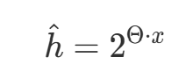
[Figure 1: Half-life regression formula]
h is the estimated half-life, x is the feature vector of the learning history (such as the number of times used correctly without a hint and the number of mistakes), and Θ is the vector of weight parameters for each feature.
Based on Ebbinghaus's forgetting-curve model, "mastery (recall probability p)" after a certain gap (elapsed time) since the last learning (use in conversation) is defined by the following formula.
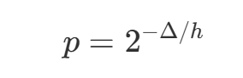
[Figure 2: Mastery formula]
Δ is the time (in days) since the expression was last used in conversation, and h is its half-life.
Here, we estimate the "half-life" at which learned words begin to fade from memory, and prioritize displaying those whose probability of correct recall has dropped to 50%. That is, items with p of 0.5 or less are automatically listed at the top.
Then, when the number of times the expression was used in conversation without pressing the hint button exceeds a certain threshold—specifically, when it has been used correctly in conversation 5 times without ever using a hint, and the expression's half-life (h) calculated by the HLR model reaches 180 days (half a year) or more—mastery is considered to be at MAX, and the expression is automatically removed from the memos.
The hints include not only those words but also example sentences that combine memorized syntax patterns and idioms, so that the user can review syntax, idioms, and words together at once and actively use those expressions.
The number of expressions the user has learned is also shown on a progress dashboard, as an indicator of current language ability.
This system can be divided into the following five steps.
①Indexing the Input
First, when the user enters a long passage into a memo, we ask the LLM to split it into words / idioms / syntax patterns and return them in a fixed JSON format, then save the words, idioms, and syntax patterns together.
Next, each classified element is converted into a "vector" that represents its meaning numerically and saved in SQLite (used as a vector database). This enables context-based search rather than simple keyword matching.
②Extracting Hints
During real-time conversation, the moment the AI asks a question, the RAG retriever runs and computes the "semantic closeness" between the AI's question and each expression in the memos. For a question about "fruit," for example, this excludes "car" and extracts highly relevant expressions such as "apple" and "juicy."
Using half-life regression, the extracted candidates whose current probability of correct recall has dropped to 50%—based on the time since last use and the "half-life" indicating memory strength—are displayed at the top with priority.
③Presenting Hints
Finally, rather than just showing words, the LLM combines the top-ranked words, syntax patterns, and idioms and, by analyzing the current conversation with the AI, generates an example sentence that can be used as is in the current conversation. The AI's replies are played back as audio, and each reply can be replayed at will.
④Recording Interactions and Updating Mastery
If the user sees the presented hint and then uses it, it is counted as a "success." Among the interaction features in the HLR model (weights related to the individual user's learning history), the weight for the number of correct answers is increased—but with a lower weight than a success without a hint. The memory is judged to have been reinforced, and the interval until the expression is presented again (the half-life) is extended slightly. Finally, the recall probability is reset and begins decaying again based on the new half-life. However, this is not counted toward the mastery condition of "5 successes without a hint."

If the user saw the presented hint but did not use the expression at all, it is counted as a "failure." Among the interaction features in the HLR model (weights related to the individual user's learning history), the weight for the number of incorrect answers (a negative weight) is increased. The memory is judged to have been forgotten, and the half-life becomes shorter. Finally, the recall probability stays low, so the next time the AI asks a question in conversation, the expression surfaces again as a high-priority "hint candidate." This is not counted toward the mastery condition of "5 successes without a hint."

If the user was able to use a memo expression without needing a hint, the weight for the number of correct answers among the interaction features in the HLR model (weights related to the individual user's learning history) is increased substantially. Finally, the recall probability is reset and begins decaying again based on the new half-life, and the period until it is shown next is greatly extended. This counts toward the mastery condition of "5 successes without a hint"; when this count reaches 5 and the calculated half-life is 180 days or more, mastery is considered to be at MAX and the expression is automatically removed from the memos.
⑤Updating the Progress Dashboard
The number of mastered expressions and the level of mastery are visualized on the progress dashboard.
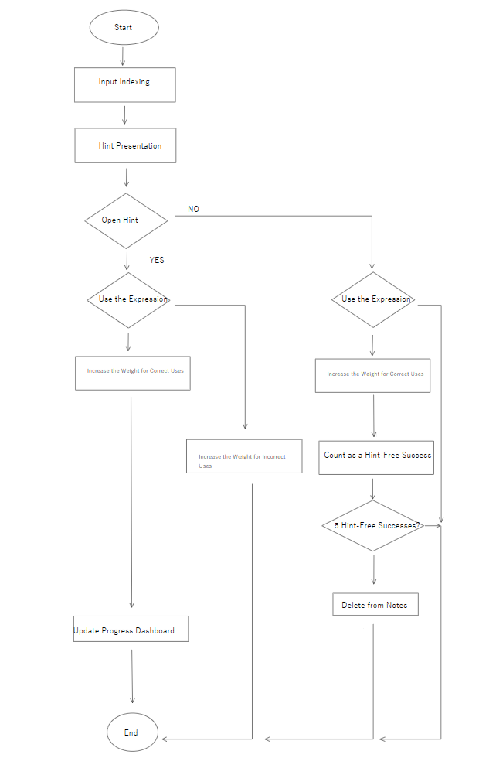
[Figure3,System dialog]
This time, the design is based on the transcript of the real-time conversation, and the grammar-correction feature built into the real-time conversation feature is paused while hints are being used.
In the evaluation, we measure each component's accuracy (RAGAS), latency, and cost, and work to improve accuracy.
RAGAS is a reference-free evaluation framework—it does not need reference data (human-made correct answers)—for automatically evaluating RAG (retrieval-augmented generation) systems. (Abstract, Shahul Es, Jithin James, Luis Espinosa-Anke, Steven Schockaert, 2023)

The endpoint for the real-time conversation feature is as follows.
This function captures the user's voice, transcribes it on the frontend, and then generates an AI response with audio playback and a corresponding text transcription.

#== リアルタイム会話機能 ==#
@app.websocket("/realtime")
async def realtime(websocket:WebSocket,token:str = ""): #エンドポイントが起動後にこの関数のみ自動で処理される（ベースシステム）
try:
user = verify_token(token)
except HTTPException:
await websocket.close(code=1008)
return
if count_usage(user["sub"],"/realtime") > LIMITS["/realtime"]:
await websocket.close(code =1008)
return
await websocket.accept()#接続を受け入れる
first = await websocket.receive_text()#最初のメッセージを受け取り、first変数に入れる
config = SessionConfig(**json.loads(first))
if ENABLE_CODE_ANALYSIS:
start_watcher(config.watchPath)#UIで指定した作業フォルダを監視する。
instructions = build_instructions(config)#指示文を作る

gemini_config = {
"response_modalities":["AUDIO"],#返事を音声にする
"system_instruction":instructions,#指示文を入れる
"input_audio_transcription":{"language_codes":[config.targetLang]},#自分の発言を文字起こしする
"output_audio_transcription":{},#AIの発言を文字起こしする
}
if ENABLE_CODE_ANALYSIS:
gemini_config["tools"] = [CODE_TOOL]
print("文字起こし言語",gemini_config["input_audio_transcription"])
async with client.aio.live.connect(model = MODEL,config = gemini_config) as session:
audio_buffer = bytearray()#音声用のリスト

async def frontend_to_gemini():
try:
while True:
raw = await websocket.receive_text()#メッセージを受け取る
msg = json.loads(raw)#辞書化して見れる形にする
if msg.get("type") == "input_audio_buffer.append":#フロントからの送信が音声である場合
pcm = base64.b64decode(msg["audio"])#メッセージの中の音声部分msg["audio"]を、生バイトに戻す
audio_buffer.extend(pcm)
await session.send_realtime_input(
audio = types.Blob(data=pcm,mime_type="audio/pcm;rate=16000")
)
except WebSocketDisconnect:#切れたら止める
pass

async def gemini_to_frontend():
user_text = ""#自分の発言を貯める
ai_text = ""#AIの発言を貯める
try:
while True:
async for response in session.receive():
if response.tool_call:#コード分析関数の実行要求が来たか検知する
print("デバック")
print("デバックの中身",response.tool_call.function_calls)
responses = []#Geminiに結果を送信する

for fc in response.tool_call.function_calls:#実行要求を一つ一つ実行
print("デバック2")
result = await analyze_code(fc.args.get("request",""),config.targetLang)
print("analyze結果（デバック）",result)
if result["code"]:#返答にコードがあればフロントに送信
await websocket.send_text(json.dumps({
"type":"code_analysis",#フロント表示用
"code":result["code"],
}))
responses.append(types.FunctionResponse(
id=fc.id,#どの実行要求に対する返事か
name = fc.name,
response={"result": result["summary"]},
))
await session.send_tool_response(function_responses=responses)#Geminiに要約を返す
continue
if response.data is not None:#何か音声があれば以下を実行する
b64 = base64.b64encode(response.data).decode()#バイトをbase64に直す
await websocket.send_text(json.dumps({
"type":"response.output_audio.delta",
"delta":b64,
}))
sc = response.server_content

if sc is None:#文字情報が無ければ、そのまま飛ばして継続
continue
if sc.input_transcription and sc.input_transcription.text:#そもそも文字起こしがあり、その中に文字があれば、自分の発言を貯める
user_text += sc.input_transcription.text
turn_id = str(time.time())#この発言のID
utterance_audio=bytes(audio_buffer)#この発言の音声をコピー
audio_buffer.clear()#次の発言用に空にする
await websocket.send_text(json.dumps({
"type":"conversation.item.input_audio_transcription.completed",
"transcript":user_text,
"id":turn_id,
}))
asyncio.create_task(analyze_turn(user_text,utterance_audio,websocket,config,turn_id))

if sc.output_transcription and sc.output_transcription.text:#AIの発言に文字起こしがあり、その中に文字があれば、AIの発言を貯める
ai_text += sc.output_transcription.text
await websocket.send_text(json.dumps({
"type":"response.output_audio_transcript.done",
"transcript":ai_text,
}))
if sc.interrupted:#ユーザーが途中で割り込んだら
await websocket.send_text(json.dumps({
"type":"interrupted",
"transcript":ai_text,
}))
ai_text=""#途中で切れたのでリセット

if sc.turn_complete:#一区切りが完了したら
await websocket.send_text(json.dumps({
"type":"response.output_audio_transcript.finish",
"transcript":ai_text,
}))
user_text = ""#リセットする
ai_text=""#リセットする
audio_buffer.clear()#AIの返事ぶんの音声を捨てる（次の発話をきれいに録るため）
except Exception as e:
print("gemini_to_frontend エラー",e)

task_a = asyncio.create_task(frontend_to_gemini())
task_b = asyncio.create_task(gemini_to_frontend())
await asyncio.wait({task_a, task_b}, return_when=asyncio.FIRST_COMPLETED)
task_a.cancel()
task_b.cancel()

The overall conversation flow looks like this.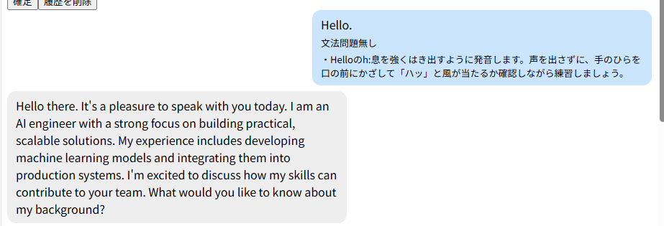

The real-time conversation feature comes with built-in functionality to analyze the grammar and pronunciation of the user's speech and provide feedback.
The following function implements an algorithm that determines which analysis function to invoke: check_grammar for grammar analysis or pronunciation_advice for pronunciation analysis. If the user's grammar is incorrect, it triggers the grammar analysis function first. If the grammar is correct, it proceeds to the pronunciation analysis function.

##== アドバイス関数を司令する関数 ==##
async def analyze_turn(user_text,utterance_audio,websocket,config:SessionConfig,turn_id):
result = await check_grammar(user_text,websocket,config,turn_id)
if result and result.get("correct") and utterance_audio:#文法OK＆音声があるとき
try:
weak = await asyncio.to_thread(assess_pronunciation,utterance_audio,user_text)
except Exception as e:
print("発音採点 エラー",e)
weak = None
if weak:#弱点があるとき
await pronunciation_advice(weak,websocket,config,turn_id)
elif weak == "":#認識OKだが弱点ゼロ→発音問題無し
await websocket.send_text(json.dumps({
"type":"pronunciation_feedback",
"result":json.dumps({"advice":[]}),#空リスト＝問題なし
"id":turn_id,
}))

The output is shown below. If the grammar is correct, the system returns corrections and feedback on the user's pronunciation.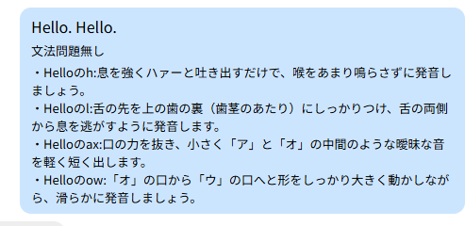
The function that provides specific grammar advice is shown below. It is designed to ensure that the LLM responds in the user's native language, which is selected on the frontend. Additionally, the response is handled asynchronously to prevent the LLM's real-time conversation functionality from being interrupted.
##== 文法アドバイス ==##
async def check_grammar(text,websocket,config:SessionConfig,turn_id):
prompt = (
"次の文章が文法的に正しいか判定して、必ずJSONだけで返す:\n"
'{"correct":true/false,"corrected":"修正分","explanation":"理由の解説"}\n'
f"explanationは{config.explainLang}で書くこと\n"
f"文:{text}"
)
try:
response = await client.aio.models.generate_content(#非同期にすることで、他の処理（特にリアルタイム会話）が止まらないようにする
model=GRAMMER_MODEL,
contents = prompt,
config=types.GenerateContentConfig(
response_mime_type = "application/json",#形式（JSON）
temperature = 0.2,#答えのブレ具合（低いと堅実）
)
)
await websocket.send_text(json.dumps({
"type":"grammar_feedback",
"result":response.text,#判定結果のJSON文字列
"id":turn_id,#どの発言に対する訂正か判別する
}))
return json.loads(response.text)

except Exception as e:
return None

The pronunciation correction function works in a similar way. First, it uses Azure Whisper's pronunciation assessment feature to recognize the audio. If the audio cannot be recognized, the function returns on the assumption that there are no pronunciation weaknesses. If the audio is successfully recognized, it extracts only the pronunciation assessment results and processes each word in the sentence individually.
For example, for the sentence "I think...", the function processes the words and their phonemes as follows:
- w=I
- w=think (p=th, p=i, p=n, p=k)
- w=water (p=w, p=ao, p=t, p=er)
It then examines each phoneme. If p.accuracy_score is below 80, the phoneme is identified as a weakness and added to the initially empty weak[] array.
Finally, the collected results are combined into a single string and returned.
This approach stores only the pronunciation assessment results (words, phonemes, and scores) from the initial audio recognition. In this implementation, any phoneme with a score below 80 is identified as a pronunciation weakness.

##== 発音チェック(Azuraに音素レベルで採点してもらう) ==##
def assess_pronunciation(pcm,reference):
speech_config = speechsdk.SpeechConfig(subscription=AZURE_KEY,region=AZURE_REGION)
#一時ファイルを使わず、音声(pcm)を直接Azureに流す（16kHz・16bit・モノラル）
stream_format = speechsdk.audio.AudioStreamFormat(samples_per_second=16000,bits_per_sample=16,channels=1)
push_stream = speechsdk.audio.PushAudioInputStream(stream_format)
push_stream.write(pcm)#音声データを流し込む
push_stream.close()#これで終わり、と伝える
audio_config = speechsdk.audio.AudioConfig(stream=push_stream)
pron_config = speechsdk.PronunciationAssessmentConfig(
reference_text=reference,#お手本＝文字起こし
grading_system=speechsdk.PronunciationAssessmentGradingSystem.HundredMark,#100点単位で採点
granularity=speechsdk.PronunciationAssessmentGranularity.Phoneme,#音素まで細かく
)
recognizer = speechsdk.SpeechRecognizer(speech_config=speech_config,audio_config=audio_config)
pron_config.apply_to(recognizer)
result = recognizer.recognize_once()

if result.reason != speechsdk.ResultReason.RecognizedSpeech:
return None#認識できなかった（弱点ゼロとは区別する）
pron = speechsdk.PronunciationAssessmentResult(result)
weak = []#弱点をためるリスト
for w in pron.words:
for p in w.phonemes:
if p.accuracy_score < 80:
weak.append(f"{w.word}の{p.phoneme}({int(p.accuracy_score)}点)")
return "、".join(weak)

At this stage, the assessment results are still presented in terms of words, phonemes, and scores, which may be difficult for users to understand. We will further refine the explanation to make the results easier for users to understand.

##== 発音アドバイス==##
async def pronunciation_advice(weak_spots,websocket,config:SessionConfig,turn_id):
prompt = (
"これは目標言語学習者の発音の弱点データです。各弱点について、口や舌の動かし方を初心者にもわかる具体的なアドバイスにして。必ずJSONだけで返す:\n"
'{"advice":[{"target":"対象の単語や音","tip":"直し方"}]}\n'
f"tipは{config.explainLang}で書くこと\n"
f"弱点データ:{weak_spots}"
)
try:
response = await client.aio.models.generate_content(#非同期にすることで、他の処理（特にリアルタイム会話）が止まらないようにする
model=PRON_MODEL,
contents = prompt,
config=types.GenerateContentConfig(
response_mime_type = "application/json",#形式（JSON）
temperature = 0.2,#答えのブレ具合（低いと堅実）
)
)
await websocket.send_text(json.dumps({
"type":"pronunciation_feedback",
"result":response.text,#判定結果のJSON文字列
"id":turn_id,#どの発言に対する訂正か判別する
}))

except Exception as e:
print("発音アドバイス エラー",e)

Next, we implement a function to save notes.

When the loop runs, for example, if result["items"] = [juicy, juicy], the first occurrence of juicy is added to new_items because it does not yet exist in the database. However, when the second occurrence is processed, the first juicy has not yet been saved to the database, so it is added to new_items again.

To prevent this, we first store each expression in a variable before saving it to the database. If the expression already exists in that variable, we skip the database INSERT operation.

This variable is used only during the loop to keep track of the expressions that have already been processed. Whenever a duplicate expression appears during processing, it is skipped.

As a result, even if the user enters something like "AI and AI," only "AI" is displayed.

#== メモを保存する機能 ==#
@app.post("/memo")
def save_memo(item:MemoIn,user:dict = Depends(limited_user)):
user_id = user["sub"]#ログイン中のユーザーID
result = split_memo(item.text)
conn = get_conn()

#重複を除いた新しい要素だけを集める
new_items = []#新しい要素を格納する変数
seen_texts = set()#同じ値が重複しない集合を作成
for el in result["items"]:
text = el["text"]#表現のみ格納
exists = conn.execute("SELECT 1 FROM memo_item WHERE user_id = ? AND text = ?",(user_id,el["text"],)).fetchone()
if not exists and text not in seen_texts:#DBにも無く、今回の処理中にも重複して無ければ
new_items.append(el)#表現が重複していなければ、その値を新しい要素を格納する変数に格納する
seen_texts.add(text)#一時的に今回の処理の間だけ表現を保存
#新しい要素のtextをまとめてベクトル化する
if new_items:
vectors = embed_texts([el["text"] for el in new_items])
for el,vector in zip(new_items,vectors):
conn.execute("INSERT INTO memo_item(user_id,type,text,vector) VALUES(?,?,?,?)",(user_id,el["type"],el["text"],vector,))
conn.commit()
conn.close()
return{"status":"SAVED"}#フロントにJSONで返答する

Next, we will create a dashboard to display the user's learning progress, including which expressions have been saved as notes and how much vocabulary the user has learned overall.

#== 進捗ダッシュボードに必要な情報を取得する機能 ==#
@app.get("/dashboard")
def dashboard(user:dict = Depends(get_current_user)):
user_id = user["sub"]
conn = get_conn()
rows = conn.execute("SELECT id,type,text,hint_free_success FROM memo_item WHERE user_id = ?",(user_id,)).fetchall()
mastered_count = conn.execute("SELECT COUNT(*) FROM mastered WHERE user_id = ?",(user_id,)).fetchone()[0]#masterdから習得した表現（行）の数を習得し、(?.)タプルから[0]で?のみ取得する
conn.close()
learning = [{"id":id_,"type":type_,"text":text_,"hint_free_success":hfs_} for id_,type_,text_,hfs_ in rows]#rows = [(1,"word","juicy",2), (2,"idiom","get rid of",0)]から{"id":1,"type":"word","text":"juicy","hint_free_success":2},{"id":2,"type":"idiom","text":"get rid of","hint_free_success":0}のように(id, type, text, hint_free_success)の各行をid_, type_, text_, hfs_の4つの変数に分けて取り出し、{"id":id_, "type":type_, "text":text_, "hint_free_success":hfs_}という辞書を作る
return{"mastered_count":mastered_count,"learning":learning}

The progress dashboard looks like this.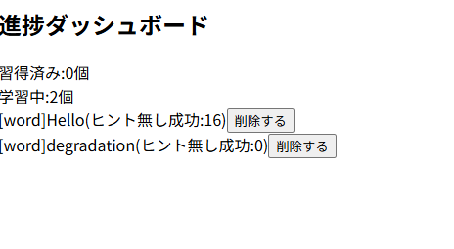

Next, we will implement the note deletion functionality.

#== メモの表現を削除する機能 ==#
@app.delete("/delete")
def delete_memo(item:DeleteIn,user:dict = Depends(get_current_user)):
conn = get_conn()
conn.execute("DELETE FROM memo_item WHERE id=? AND user_id=?",(item.id,user["sub"]))
conn.commit()
conn.close()
return{"status":"deleted"}

Next, we will implement the hint generation feature.

Here, we will retrieve and present the top-ranked hints that are most semantically similar to the AI's question.

#== ヒントを提示する機能 ==#
@app.post("/hint")
def get_hint(item:HintIn,user:dict = Depends(limited_user)):
q_vec = json.loads(embed_texts([item.query])[0])#queryの一件目[0]をベクトル化し、それをPytonのリストに戻す
conn = get_conn()
rows = conn.execute("SELECT type,text,vector,good,bad,julianday('now')-julianday(last_seen_at) AS delta_days FROM memo_item WHERE user_id = ?",(user["sub"],)).fetchall()#全メモから拾い
conn.close()
scored=[]
for type_,text_,vector_,good_,bad_,delta_days_ in rows:#書くメモと類似度を計算
if not vector_:#vectorが空（古いメモ）は飛ばす
continue
v = json.loads(vector_)
sim = cosine_similarity(q_vec,v)
p = recall_probability(good_,bad_,delta_days_)
scored.append((sim,p,type_,text_))
scored.sort(key=lambda s:s[0], reverse=True)#類似度s[0]が高い順に並べる。（reverse=Trueで適用する）特にsimが高い順に並べる
relevant = scored[:5]#上位5件
relevant.sort(key=lambda s:s[1])#さらにその中で想起確率s[1]が低い順
top = relevant[:4]#さらにその中の上位4件
hints = [{"type":t,"text":tx} for sim,p,t,tx in top]
example = make_example(hints,item.query)
return {"hints":hints,"example":example.get("example","")}

The output looks like this.

Additionally, to enable the hint feature to search for expressions in the user's notes that are semantically similar to the AI's responses, we first implement a function that converts the saved expressions into vector embeddings to support RAG (Retrieval-Augmented Generation).

#== メモした表現を意味ベクトル化する関数 ==##
def embed_texts(texts):
response = openai_client.embeddings.create(
model = "text-embedding-3-large",
input = texts,
)
return[ json.dumps(d.embedding)for d in response.data]

Next, we will implement a function that calculates the cosine similarity between two vectors: the vector embeddings of the saved notes and the vector embedding of the AI's response.
#== 二つのベクトルの意味的な近さを測るコサイン類似度関数 ==##
def cosine_similarity(a,b):
dot = sum(x*y for x,y in zip(a,b))#各要素をかけた合計の内積
norm_a = math.sqrt(sum(x*x for x in a))#aの長さ
norm_b = math.sqrt(sum(x*x for x in b))#bの長さ
return dot/(norm_a * norm_b)

Next, this application adopts the HLR model, which measures how consistently a user can recall and use vocabulary over time by tracking the intervals between successful uses.
#== HLRの重み ==#
THETA_BIAS = 0.0 # 基準
THETA_GOOD = 1.0 # 正解回数の重み
THETA_BAD = -1.0 # 不正解回数の重み

#== その他の定数 ==#
DELETE_MAX = 5#ヒント無しで成功できた回数の最高値
HALF_LIFE_MAX = 180#半減期の最高値

#== 今のHLRを計算する ==#
def recall_probability(good,bad,delta_days):
if delta_days is None:#一度も使っていない（Δ=0）新規メモは最優先で出す
return 0
h = 2**(THETA_BIAS + THETA_GOOD*math.sqrt(good) + THETA_BAD*math.sqrt(bad))
return 2**(-delta_days/h)#想起確率（０から１）

Additionally, we will implement a feature that reranks vocabulary that has not been used recently (indicating a lower level of mastery) based on its relevance to the AI's response, and then uses an LLM to generate appropriate example sentences using the selected vocabulary.
#== 上位の表現を組み合わせて、今の会話で使える例文をLLMが生成する ==#
def make_example(hints,ai_text):
exprs = ",".join(f"{h['type']}:{h['text']}" for h in hints)#表現を一行にして繋げる
promot = (
"外国語学習のヒントを作ります。次のAIの回答文への返答として、下の表現をできるだけ使った自然な例文を一つ作りなさい。必ずJSONだけで返してください:\n"
'{"example":"作った例文","used":["使った表現",....]}\n'
f"AIの発言:{ai_text}\n"
f"使ってほしい表現:{exprs}\n"
)
response = client.models.generate_content(
model= GRAMMER_MODEL,
contents = promot,
config = types.GenerateContentConfig(
response_mime_type = "application/json",#形式（JSON）
temperature = 0.2,#答えのブレ具合（低いと堅実）
),
)
return json.loads(response.text)

Furthermore, the following function uses an LLM to identify which expressions were used in the user's utterance and returns the expressions that were actually used, allowing the HLR model to be updated.

#== ユーザーの発言で使われた表現をLLMに判定させる ==#
def judge_used(utterance,expressions):
promot = (
"ユーザーの発言と、注目している表現リストがあります。発言の中で実際に使われた表現だけを返して。また活用形・言い換えも「使った」とみなす。また必ずJSONだけで返す:\n"
'{"used":["実際に使われた表現",...]}\n'
f"発言:{utterance}\n"
f"表現リスト:{expressions}"
)
response = client.models.generate_content(
model= GRAMMER_MODEL,
contents = promot,
config = types.GenerateContentConfig(
response_mime_type = "application/json",#形式（JSON）
temperature = 0.2,#答えのブレ具合（低いと堅実）
),
)
return json.loads(response.text).get("used",[])#実際に使われた表現
Finally, we will implement a function in the following endpoint that tracks hint usage and updates the user's mastery level accordingly.

#== ヒントの使用状況を判定して習得度を更新する機能 ==#
@app.post("/interaction")
def record_interaction(item:Interaction,user:dict = Depends(limited_user)):
user_id = user["sub"]
conn = get_conn()
rows = conn.execute("SELECT id,text,good,bad,hint_free_success FROM memo_item WHERE user_id = ?",(user_id,)).fetchall()#全メモを取り出す
all_texts = [r[1] for r in rows]#textのみ取り出す
used = judge_used(item.utterance,all_texts)#実際に使われた表現
for id_,text_,good_,bad_,hint_free_success_ in rows:
is_used = text_ in used#実際に使われたか
is_shown = text_ in item.shown#ヒントで見せたか
if is_used and is_shown:#①ヒントを使った成功
conn.execute("UPDATE memo_item SET good=good+1, last_seen_at=datetime('now') WHERE id=? AND user_id=?",(id_,user_id))
elif is_used and not is_shown:#③ヒント無しで成功
conn.execute("UPDATE memo_item SET good=good+2, hint_free_success=hint_free_success+1, last_seen_at=datetime('now') WHERE id=? AND user_id=?",(id_,user_id))
if hint_free_success_ + 1 >= DELETE_MAX and recall_probability(good_+2, bad_, HALF_LIFE_MAX) >= 0.5:#習得済み
conn.execute("DELETE FROM memo_item WHERE id=? AND user_id=?",(id_,user_id))
conn.execute("INSERT INTO mastered(user_id,text) VALUES(?,?)",(user_id,text_))
elif is_shown and not is_used:#②失敗（見たのに使わなかった）
conn.execute("UPDATE memo_item SET bad=bad+1 WHERE id=? AND user_id=?",(id_,user_id))
conn.commit()
conn.close()
return {"status":"updated","used":used}

Results and Evaluation
Among the features implemented in this project, two major challenges were encountered:* The RAGAS metrics could not be used directly for evaluating the implemented RAG system.* The answer_relevancy score, which measures whether the generated hint is appropriate and relevant to the AI's question, was lower than the average.First, RAG was implemented in Mingo so that relevant expressions saved in the user's memos could be selected in response to the AI's questions. To evaluate whether this functionality achieved the intended level of accuracy, RAGAS, a framework for evaluating RAG systems, was used.However, it was found that four of the five RAGAS metrics were not suitable for evaluating Mingo's RAG functionality. These metrics were faithfulness, which evaluates whether an answer is supported by the retrieved information; context_recall, which evaluates whether the necessary information for answering a question was retrieved without omissions; llm_context_precision_with_reference, which evaluates whether the retrieved information is relevant when compared with a reference answer; and llm_context_precision_without_reference, which evaluates whether the retrieved information is relevant for answering the question.The fundamental reason is that RAGAS is primarily designed to evaluate text-retrieval-based RAG systems. For example, if a user asks a document-based RAG system, “How many days of paid leave are available?”, the system may retrieve the fact “Employees are entitled to 20 days of paid leave” from a document and generate the answer “20 days.”In contrast, Mingo uses RAG for a different purpose. For example, if the AI asks, “What did you do over the weekend?”, Mingo selects a relevant expression from the user's saved vocabulary, such as “hang out with,” and uses it to generate an appropriate example sentence such as “I hung out with my friends.”The faithfulness metric is not appropriate in this situation because “hang out with” is not evidence of a factual statement. It is simply a conversational hint intended to help the user formulate an answer, rather than information that describes a fact.Similarly, context_recall is calculated by first dividing a reference answer into several factual statements and then using an LLM to determine whether each fact can be supported by the retrieved contexts. The metric is then calculated as the number of supported facts divided by the total number of facts.In this project, for example, a reference answer was prepared for the AI's question, “What did you do over the weekend?” The reference answer was: “I hung out with my friends and went hiking.” This answer can be divided into two facts:* Fact 1: The user hung out with friends.* Fact 2: The user went hiking.Suppose the retrieved memo expressions are:“hang out with,” “go hiking,” “grab a coffee,” ...The problem is that “hang out with” is not a factual statement; it is a vocabulary expression. The existence of the expression “hang out with” in the user's memo is different from the fact that “the user hung out with friends.” Therefore, an LLM cannot appropriately determine whether this expression provides evidence for a factual statement. In this case, “hang out with” is simply a vocabulary item and does not explicitly state either Fact 1 or Fact 2.The same problem occurs with llm_context_precision_with_reference. Because there is only one reference answer, the retrieved expression may be judged as irrelevant even though it is useful as a language-learning hint. llm_context_precision_without_reference has a similar problem. The information about what the user actually did over the weekend is known only by the user, not by the saved memo. The memo helps the user determine how to express an answer, but it does not contain the actual content of what the user should say.Therefore, instead of using these unsuitable metrics, three metrics were introduced specifically for evaluating Mingo's functionality. The first is expression_usage_rate, which measures whether the selected memo expressions were actually used in the generated example sentence. It is calculated as the number of selected expressions used in the example sentence divided by the total number of selected expressions. The second is naturalness_score, which evaluates how natural the generated example sentence is to a native English speaker, with an LLM assigning a score out of 10. Finally, answer_relevancy, which measures the relevance of the generated answer to the AI's question, was retained.Initially, the answer_relevancy score was below the average. It was hypothesized that this was caused by attempting to force too many selected vocabulary expressions into a single example sentence, which reduced the relevance of the generated answer.Therefore, the number of vocabulary expressions retrieved was reduced from the current five to four. As a result, the answer_relevancy score increased by more than 40% without reducing the expression_usage_rate. In addition, the naturalness_score improved by 2.1%.This adjustment demonstrated that reducing the number of retrieved expressions could improve the relevance and naturalness of the generated examples while maintaining the effective use of the selected vocabulary.

Metric | Before Adjustment | After Adjustment
expression_usage_rate | 1.0 | 1.0
naturalness_score | 9.4 | 9.6
answer_relevancy | 0.4921 | 0.6922
[Figure4, Comparison of Metrics]
First, we will conduct integration testing to verify that data is properly isolated between users and that the entire process, from memo creation to deletion, works correctly.Here, integration testing focuses on verifying data isolation between users, while system testing focuses on validating the complete workflow from memo creation to deletion.To test data isolation, we will first confirm that User B's memos do not appear on User A's dashboard. We will then verify that when User B attempts to delete User A's memo, User A's memo remains intact.The following endpoints will be tested.First, the endpoint for saving memos.
#== メモを保存する機能 ==#
@app.post("/memo")
def save_memo(item:MemoIn,user:dict = Depends(limited_user)):
user_id = user["sub"]#ログイン中のユーザーID
result = split_memo(item.text)
conn = get_conn()

#重複を除いた新しい要素だけを集める
new_items = []#新しい要素を格納する変数
seen_texts = set()#同じ値が重複しない集合を作成
for el in result["items"]:
text = el["text"]#表現のみ格納
exists = conn.execute("SELECT 1 FROM memo_item WHERE user_id = ? AND text = ?",(user_id,el["text"],)).fetchone()
if not exists and text not in seen_texts:#DBにも無く、今回の処理中にも重複して無ければ
new_items.append(el)#表現が重複していなければ、その値を新しい要素を格納する変数に格納する
seen_texts.add(text)#一時的に今回の処理の間だけ表現を保存
#新しい要素のtextをまとめてベクトル化する
if new_items:
vectors = embed_texts([el["text"] for el in new_items])
for el,vector in zip(new_items,vectors):
conn.execute("INSERT INTO memo_item(user_id,type,text,vector) VALUES(?,?,?,?)",(user_id,el["type"],el["text"],vector,))
conn.commit()
conn.close()
return{"status":"SAVED"}#フロントにJSONで返答する

Next, the functionality for retrieving the data required by the progress dashboard.
#== 進捗ダッシュボードに必要な情報を取得する機能 ==#
@app.get("/dashboard")
def dashboard(user:dict = Depends(get_current_user)):
user_id = user["sub"]
conn = get_conn()
rows = conn.execute("SELECT id,type,text,hint_free_success FROM memo_item WHERE user_id = ?",(user_id,)).fetchall()
mastered_count = conn.execute("SELECT COUNT(*) FROM mastered WHERE user_id = ?",(user_id,)).fetchone()[0]#masterdから習得した表現（行）の数を習得し、(?.)タプルから[0]で?のみ取得する
conn.close()
learning = [{"id":id_,"type":type_,"text":text_,"hint_free_success":hfs_} for id_,type_,text_,hfs_ in rows]#rows = [(1,"word","juicy",2), (2,"idiom","get rid of",0)]から{"id":1,"type":"word","text":"juicy","hint_free_success":2},{"id":2,"type":"idiom","text":"get rid of","hint_free_success":0}のように(id, type, text, hint_free_success)の各行をid_, type_, text_, hfs_の4つの変数に分けて取り出し、{"id":id_, "type":type_, "text":text_, "hint_free_success":hfs_}という辞書を作る
return{"mastered_count":mastered_count,"learning":learning}

Finally, the functionality for deleting memos.
#== メモの表現を削除する機能 ==#
@app.delete("/delete")
def delete_memo(item:DeleteIn,user:dict = Depends(get_current_user)):
conn = get_conn()
conn.execute("DELETE FROM memo_item WHERE id=? AND user_id=?",(item.id,user["sub"]))
conn.commit()
conn.close()
return{"status":"deleted"}

First, the database connection is currently hardcoded to memo.db.
##== DBへの接続を開く関数==##
def get_conn():
return sqlite3.connect("memo.db")
In other words, the application always opens a database file with the same name. If we run tests without making any changes, they may use the database containing development data.Therefore, we will make it possible to switch between database files through configuration settings.
##== DBへの接続を開く関数==##
def get_conn():
db_path = os.environ.get("MEMO_DB_PATH", "memo.db") # 環境変数からDBパスを取得、なければデフォルトでmemo.db
return sqlite3.connect(db_path)
Here, .get("MEMO_DB_PATH", "memo.db") means that if the MEMO_DB_PATH environment variable exists, its value is returned; otherwise, "memo.db" is returned.Currently, the application also initializes the database for memos and hints immediately when the application starts.
init_memo_db()#起動時にメモ・ヒント用のDBを起動（memo_itemとmasteredの両方を作る）
We will use .on_event("startup") to register a function that runs when the application starts. This allows the test environment to set the database path before starting the application, so that the tables are created in the test database. In production, if no environment variable is set, the application will continue to use memo.db as before.
@app.on_event("startup")#サーバーが立ち上がったときに実行する
def startup():
init_memo_db()#DBのテーブルを作る
The goal of this test is to verify that User B's memos do not appear on User A's dashboard and that User A's memo remains intact even when User B attempts to delete it.The important point here is that Users A and B must share the same database. If we use separate databases, it is natural that they cannot see each other's memos, so we cannot properly verify user-level data isolation. We use a test database to protect development data, but both Users A and B will store their memos in the same test database.First, since auth.py requires Cognito configuration at startup, we will prepare test values. This will allow pytest to load the configuration and set the test environment variables before running the tests.
import os

os.environ.update({
"COGNITO_REGION": "test-region",
"COGNITO_USER_POOL_ID": "test-pool",
"COGNITO_APP_CLIENT_ID": "test-client",
"GEMINI_API_KEY": "test-key",
"OPENAI_API_KEY": "test-key",
})

To summarize the test flow, we will create a single test database → User A creates a memo → User B creates a memo → verify what User A sees → User B attempts to delete User A's memo → verify that User A's memo still exists.First, we will import the necessary tools.
import json
from fastapi.testclient import TestClient
import main
Here, json is used to convert test vectors into JSON strings. TestClient is a testing client that starts the application and sends requests to its API. main imports backend/main.py, where the FastAPI application and the functions being tested are defined.First, we will use pytest's monkeypatch fixture to temporarily replace functions in the main module with alternative functions during testing. The basic syntax of monkeypatch.setattr is as follows.
monkeypatch.setattr(対象のモジュール, "属性名", 差し替え後の値)
During the test, when main.split_memo("memo-a") is called, it will return the following value instead of calling Gemini.
{"items": [{"type": "word", "text": "memo-a"}]}

To achieve this, I will use lambda text: ... as the replacement value. A lambda is a concise way to define a short, single-line function.
monkeypatch.setattr(main, "split_memo", lambda text:{"items": [{"type": "word", "text": "memo-a"}]})
Similarly, I will apply the same approach to the process of converting memos into vector embeddings.
monkeypatch.setattr(main,"embed_texts",lambda texts: [json.dumps([1.0, 0.0]) for _ in texts],)
For each element in texts, this creates a JSON string representing [1.0, 0.0].For example, if texts = ["memo-a", "memo-b"], the result will be ['[1.0, 0.0]', '[1.0, 0.0]'].Next, I will configure the test to use fake_get_current_user instead of the actual authentication function, get_current_user, whenever it is called.
monkeypatch.setitem(辞書, キー, 設定する値)
This dictionary stores the configuration for FastAPI's dependency override mechanism. The key is the authentication function to be replaced, and the value is the function that will be used as a replacement.
active_user = {"sub": "user-a"}
def fake_get_current_user():
return active_user

monkeypatch.setitem( main.app.dependency_overrides,main.get_current_user,fake_get_current_user,)

Here, we start the test application.
with TestClient(main.app) as client:
When the application starts, the database initialization process runs and creates the tables in the location specified by the previously configured MEMO_DB_PATH environment variable. We can then use client.post(...) and client.get(...) inside the with block to send API requests. When the block ends,the test application is shut down.
with TestClient(main.app) as client:
response = client.post("/memo", json={"text": "memo-a"})
assert response.status_code == 200

active_user["sub"] = "user-b"#ユーザーを"user-b"に切り替える
response = client.post("/memo", json={"text": "memo-b"})
assert response.status_code == 200
Here, we change active_user to User B and register memo-b through the same API.Since the database path remains unchanged, both memos are stored in the same test database. If the response status code is 200, we can confirm that the memo registration API succeeded.
a_learing = response.json()["learning"]#JSONのlearningからメモの文章だけを取り出し、["memo-a"]と一致するか確認
assert [item["text"] for item in a_learing] == ["memo-a"]#["memo-a"]と一致するか確認
Next, we switch the authenticated user back to User A and call /dashboard. We extract only the memo text from the learning field in the returned JSON and verify that it matches ["memo-a"].Next, to test whether User B can delete User A's memo, we save the memo's ID in advance.
active_user["sub"] = "user-b"
response = client.request("DELETE", "/delete", json={"id": a_memo_id})
Next, we switch back to User A and verify that only memo-a still appears on User A's dashboard. If this is confirmed, we can conclude that User B's deletion attempt did not remove User A's memo.
active_user["sub"] = "user-a"
esponse = client.get("/dashboard")
assert [item["text"] for item in response.json()["learning"]] == ["memo-a"]
At each stage, we insert assert response.status_code == 200 to determine whether the test has passed.The results of running the test are shown below.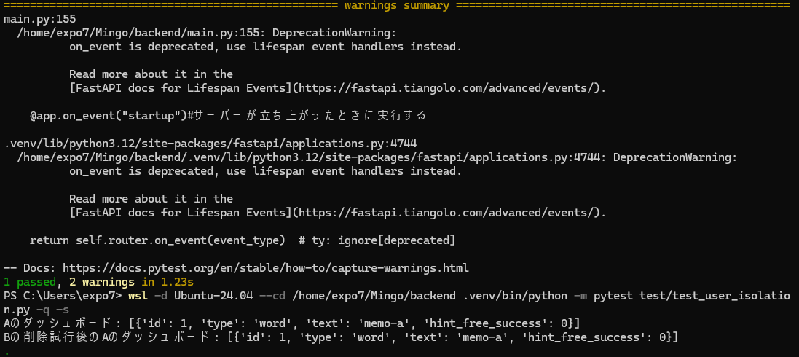
[Figure5, Test result]

The results show that the test passed successfully. When User A saved a memo, its content was stored correctly. Even after switching to User B and attempting to delete the memo, the memo remained available to User A.This approach helps ensure that multiple users can use the application without interfering with each other's data.

I would like to add a new test to the progress dashboard to measure whether the naturalness of generated example sentences decreases as the number of saved memos increases.

In the current design, the system selects the top four expressions relevant to the ongoing conversation from all the expressions saved in the user's memos and uses them to generate example sentences. As the number of saved memos increases, the selected candidates may change, potentially resulting in the use of unnatural expressions.

To investigate this possibility, I will add a test that increases the number of saved memos and measures how the naturalness_score changes. The current number of saved memos is 25. I will increase this to 50 and then 75, observing how the naturalness_score changes at each stage.

First, the current state of the saved memos is shown below.
memos = [
# --- 週末の活動系（クエリに関連） ---
"hang out with friends",
"go hiking",
"get some rest",
"grab a coffee",
"watch a movie",
"sleep in",
"do the laundry",
"go shopping",
"visit my parents",
"play video games",
"cook dinner",
"read a novel",
"go for a run",
"clean the house",
"take a nap",
# --- 無関係系（precisionのテスト用） ---
"submit a report",
"book a flight",
"fix a bug",
"attend a meeting",
"pay the rent",
"sign a contract",
"water the plants",
"renew my passport",
"file taxes",
"charge my phone",
]

The naturalness_score at this point is as follows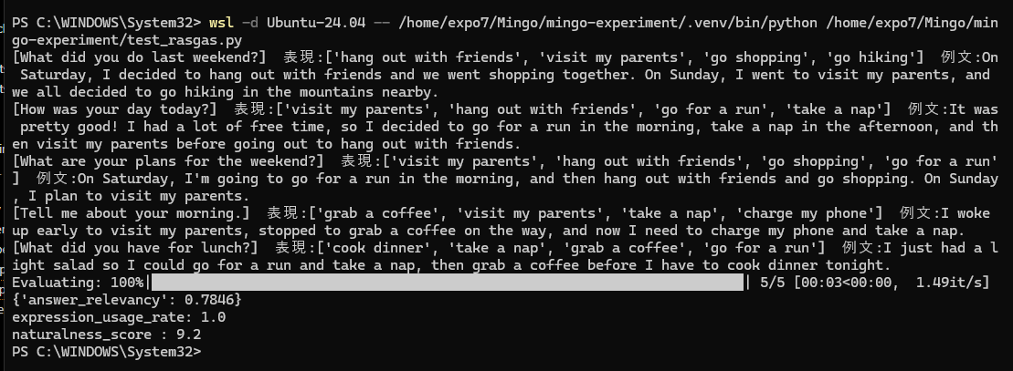
The naturalness_score was 9.2.
Next, I will increase the number of saved memos to 50.
#テスト用に入れる表現
memos = [
# --- 週末の活動系（クエリに関連） ---
"hang out with friends",
"go hiking",
"get some rest",
"grab a coffee",
"watch a movie",
"sleep in",
"do the laundry",
"go shopping",
"visit my parents",
"play video games",
"cook dinner",
"read a novel",
"go for a run",
"clean the house",
"take a nap",
# --- 追加テスト表現 ---
"visit a museum",
"bake cookies",
"try a new restaurant",
"meet up with coworkers",
"watch a live concert",
"take a road trip",
"go camping",
"take photos",
"organize my desk",
"pick up groceries",
"drop off a package",
"do yoga",
"practice the guitar",
"work on a project",
"call my sister",
"walk the dog",
"make breakfast",
"catch a train",
"miss the bus",
"return a book",
"plan a vacation",
"learn a new recipe",
"repair a bicycle",
"decorate the living room",
"check the weather",
# --- 無関係系（precisionのテスト用） ---
"submit a report",
"book a flight",
"fix a bug",
"attend a meeting",
"pay the rent",
"sign a contract",
"water the plants",
"renew my passport",
"file taxes",
"charge my phone",
]

The results are shown below, and the naturalness_score remains unchanged.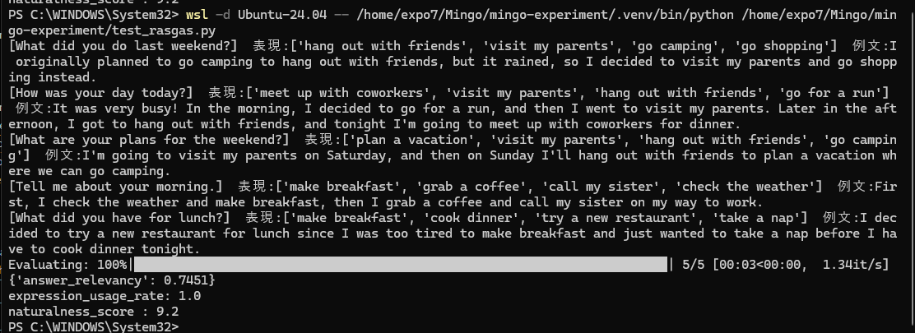

I increased the number of saved memos to 75.
memos = [
# --- 週末の活動系（クエリに関連） ---
"hang out with friends",
"go hiking",
"get some rest",
"grab a coffee",
"watch a movie",
"sleep in",
"do the laundry",
"go shopping",
"visit my parents",
"play video games",
"cook dinner",
"read a novel",
"go for a run",
"clean the house",
"take a nap",
# --- 追加テスト表現 ---
"visit a museum",
"bake cookies",
"try a new restaurant",
"meet up with coworkers",
"watch a live concert",
"take a road trip",
"go camping",
"take photos",
"organize my desk",
"pick up groceries",
"drop off a package",
"do yoga",
"practice the guitar",
"work on a project",
"call my sister",
"walk the dog",
"make breakfast",
"catch a train",
"miss the bus",
"return a book",
"plan a vacation",
"learn a new recipe",
"repair a bicycle",
"decorate the living room",
"check the weather",
# --- 追加テスト表現2 ---
"have brunch with friends",
"explore a local market",
"watch the sunset",
"go bowling",
"visit an art gallery",
"host a dinner party",
"make a playlist",
"go for a bike ride",
"water the garden",
"try a pottery class",
"volunteer at a shelter",
"buy a birthday gift",
"sort through old photos",
"take the kids to the park",
"stay at a hotel",
"order takeout",
"go ice skating",
"write in my journal",
"clean out the closet",
"attend a book club",
"pack for a trip",
"feed the cat",
"watch a documentary",
"send a thank-you note",
"pick up a prescription",
# --- 無関係系（precisionのテスト用） ---
"submit a report",
"book a flight",
"fix a bug",
"attend a meeting",
"pay the rent",
"sign a contract",
"water the plants",
"renew my passport",
"file taxes",
"charge my phone",
]

The results are as follows.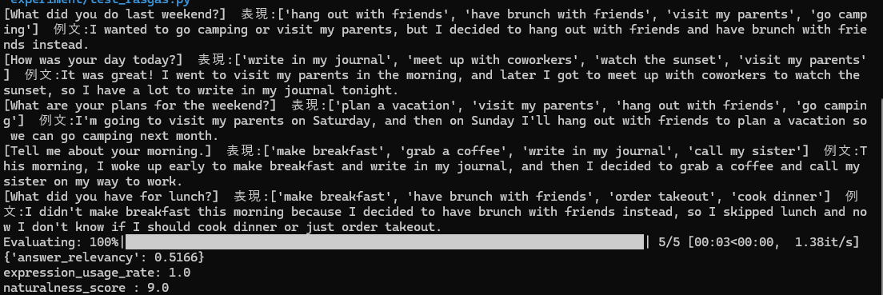
Here, we can see that the naturalness_score decreased from 9.2 to 9.0. I would like to add more vocabulary and conduct another test with 200 saved expressions.
memos = [
# --- 週末の活動系（クエリに関連） ---
"hang out with friends",
"go hiking",
"get some rest",
"grab a coffee",
"watch a movie",
"sleep in",
"do the laundry",
"go shopping",
"visit my parents",
"play video games",
"cook dinner",
"read a novel",
"go for a run",
"clean the house",
"take a nap",
# --- 追加テスト表現 ---
"visit a museum",
"bake cookies",
"try a new restaurant",
"meet up with coworkers",
"watch a live concert",
"take a road trip",
"go camping",
"take photos",
"organize my desk",
"pick up groceries",
"drop off a package",
"do yoga",
"practice the guitar",
"work on a project",
"call my sister",
"walk the dog",
"make breakfast",
"catch a train",
"miss the bus",
"return a book",
"plan a vacation",
"learn a new recipe",
"repair a bicycle",
"decorate the living room",
"check the weather",
# --- 追加テスト表現2 ---
"have brunch with friends",
"explore a local market",
"watch the sunset",
"go bowling",
"visit an art gallery",
"host a dinner party",
"make a playlist",
"go for a bike ride",
"water the garden",
"try a pottery class",
"volunteer at a shelter",
"buy a birthday gift",
"sort through old photos",
"take the kids to the park",
"stay at a hotel",
"order takeout",
"go ice skating",
"write in my journal",
"clean out the closet",
"attend a book club",
"pack for a trip",
"feed the cat",
"watch a documentary",
"send a thank-you note",
"pick up a prescription",
# --- 追加テスト表現3 ---
"spend time at the beach",
"make homemade pizza",
"go to a farmers' market",
"visit a historic site",
"play board games",
"take a cooking class",
"go kayaking",
"watch a sports game",
"plant some flowers",
"meet a friend for lunch",
"browse a bookstore",
"paint a bedroom",
"go to a comedy show",
"make a smoothie",
"ride the subway downtown",
"feed the birds",
"trim the hedges",
"build a bookshelf",
"try a new coffee shop",
"go to a flea market",
"send invitations",
"freeze leftovers",
"practice the piano",
"watch the fireworks",
"return an online order",
# --- 追加テスト表現4 ---
"visit a botanical garden",
"go for a long walk",
"make pancakes for breakfast",
"watch a comedy film",
"take a train to the coast",
"visit a nearby town",
"go paddleboarding",
"have a picnic in the park",
"try a new dessert recipe",
"listen to a podcast",
"go to a museum with friends",
"make fresh lemonade",
"walk along the river",
"visit a farmers' market",
"play tennis at the park",
"take a scenic drive",
"go to a craft fair",
"make homemade soup",
"visit a nature reserve",
"watch a classic movie",
"go for a swim",
"have dinner with my cousins",
"take a dance lesson",
"explore a hiking trail",
"make a scrapbook",
"visit a public garden",
"go to a local festival",
"try a new lunch spot",
"take a ferry ride",
"play frisbee outside",
"make decorations for a party",
"go stargazing",
"visit a science center",
"take a neighborhood walk",
"bake a loaf of bread",
"go to an outdoor market",
"watch a theater performance",
"have coffee with a neighbor",
"go fruit picking",
"make a photo album",
"visit a small bookstore",
"take a beginner yoga class",
"go on a nature walk",
"try a new board game",
"make dinner with friends",
"go to a public pool",
"watch a cooking show",
"visit a local aquarium",
"take a pottery workshop",
"go to a neighborhood barbecue",
"make a batch of muffins",
"explore a new walking route",
"visit a craft store",
"go horseback riding",
"take a family portrait",
"try a new tea shop",
"go to an open-air cinema",
"make a gift basket",
"visit a nearby lake",
"play mini golf",
"take a weekend train trip",
"go to a dance party",
"visit a local history museum",
"go birdwatching",
"have lunch on a patio",
"take a scenic bike ride",
"make a homemade dessert",
"go to a garden center",
"watch a sunset from the hill",
"visit a food truck festival",
"play badminton in the yard",
"take a short camping trip",
"make a new dinner recipe",
"go to a neighborhood cafe",
"visit a sculpture park",
"have a game night at home",
"take a walk by the beach",
"go to a local theater",
"make a playlist for a road trip",
"visit a nearby waterfall",
"try indoor rock climbing",
"have breakfast at a diner",
"go on a weekend getaway",
"take a guided city tour",
"make handmade greeting cards",
"visit a community garden",
"go to a seasonal fair",
"watch a nature documentary",
"have dessert with a friend",
"take a photography walk",
# --- 無関係系（precisionのテスト用） ---
"submit a report",
"book a flight",
"fix a bug",
"attend a meeting",
"pay the rent",
"sign a contract",
"water the plants",
"renew my passport",
"file taxes",
"charge my phone",
"approve the annual budget",
"update the project schedule",
"review a vendor invoice",
"install a security update",
"prepare a sales forecast",
"submit an expense claim",
"schedule a client presentation",
"audit the inventory records",
"draft a policy document",
"configure a network router",
]

The results are as follows.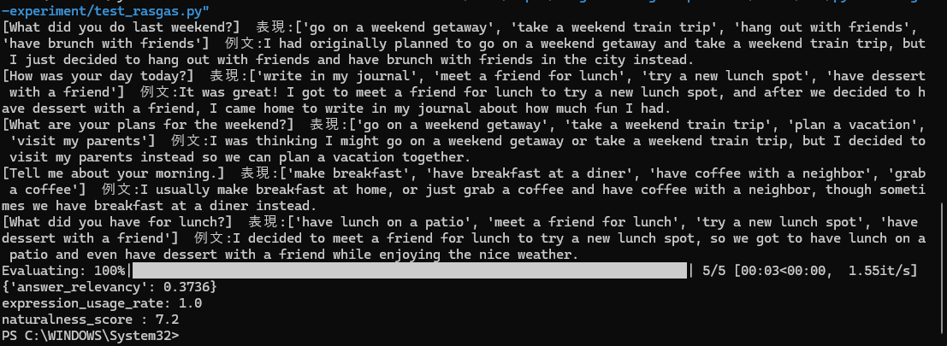

The results show that the naturalness_score decreased to 7.2. This suggests that the naturalness of generated example sentences may decrease as the number of saved memos increases. Therefore, in the future, we can expect the naturalness of example sentences to deteriorate as the number of saved memos continues to grow.

As a future improvement, I would like to refine the retrieval process. Currently, the system selects the top five memos based on cosine similarity to the user's question. Instead, I propose filtering these expressions so that only those with a relevance score of 50% or higher are selected. If fewer than five expressions meet this threshold, the system will use only those that qualify. If no relevant expressions are found, the system will generate natural sentences without forcing the use of saved memos. This approach ensures that only expressions sufficiently relevant to the user's question are provided to the language model.

To implement this improvement, I would like to explore the use of SELF-RAG (Self-Reflective Retrieval-Augmented Generation), a self-reflective generation framework developed to address the limitations of conventional RAG, such as unnecessary document retrieval and degraded responses caused by irrelevant or low-quality information (Abstract, Akari Asai).

SELF-RAG combines on-demand retrieval, in which the model determines whether external knowledge is necessary, with a self-reflection mechanism, which evaluates the retrieved documents and the generated responses. This approach aims to achieve both high factual accuracy and natural, high-quality contextual generation.

The process works as follows. First, if a question can be answered with the AI's existing knowledge, the model generates a natural response without retrieving external information. Next, the model examines the retrieved documents and discards those it considers irrelevant or noisy. Finally, it checks whether the generated response is consistent with the information in the retrieved documents, identifying potential inaccuracies or contradictions before selecting the most readable and useful response.

As a result, even when a large amount of information is available, the model can avoid unnecessary retrieval and make better use of its natural language generation capabilities when external information is not needed.

In Mingo, I believe we can apply the principle of filtering out irrelevant retrieved information to improve example sentence generation. By filtering the saved expressions in advance and excluding irrelevant memos, we can reduce noise and ensure that only sufficiently relevant expressions are used to generate example sentences.

Discussion
Based on the results, reducing the number of expressions selected from the saved memos for use as hints made it possible to generate example sentences that were more relevant to and natural in the context of the AI's responses.
These results suggest that when too many expressions are included in an example sentence, the model may prioritize using the specified expressions over maintaining relevance to the user's question, potentially resulting in unnatural example sentences.
Furthermore, when testing the system, it was observed that the conversations tended to follow similar patterns across different interactions, which also led to the repeated use of similar expressions in the generated hints.
Another limitation of the system is that the quality of the generated hints may depend on the types of expressions stored in the memos. Although certain combinations of topics and expressions may produce good results in specific contexts, the system cannot guarantee the same level of hint quality across different conversational situations.

Conclusion and Future Work

In this language-learning application, I developed a hint-generation feature that uses Retrieval-Augmented Generation (RAG) to retrieve expressions from saved memos and generate contextual hints. The system achieved above-average performance across all three evaluation criteria: naturalness of the expressions, relevance to the AI's responses, and usage rate. This made it possible to reactivate expressions saved during conversations, a task that was previously difficult to accomplish in real time. Furthermore, by visually tracking the mastery level of each expression, the system made it easier for learners to identify which expressions they should focus on using.
As potential improvements, I propose developing a system that makes hints as relevant as possible to the immediately preceding conversation. If no suitable expression can be found among the saved memos, the LLM could automatically generate an appropriate expression as a substitute, but only in such cases. I also suggest allowing a hint to be displayed only when each evaluation metric exceeds 50%. Finally, the system should address the issue of Gemini Live timing out after 15 minutes to ensure a more continuous conversation experience. Furthermore, to address the problem of declining hint quality as the number of saved memos increases, I believe that selecting only expressions with a relevance score of 50% or higher, rather than forcing the system to use five expressions, even when fewer than five meet this threshold, could ultimately improve hint quality. I also believe that adopting an approach such as SELF-RAG to evaluate relevance could be a significant step toward solving this problem.

References

Akari Asai, SELF-RAG: LEARNING TO RETRIEVE, GENERATE, AND CRITIQUE THROUGH SELF-REFLECTION

Dongliang Ding & Ahmad Muhyiddin B Yusof (2025). Investigating the role of AI-powered conversation bots in enhancing L2 speaking skills and reducing speaking anxiety: a mixed methods study.

Es, S., James, J., Espinosa-Anke, L., & Schockaert, S. (2023). RAGAS: Automated Evaluation of Retrieval Augmented Generation.

Hoepman, J.-H. (2024). Privacy Design Strategies.

Karatas, N. B. (2025). Improving second language vocabulary learning and retention by leveraging memory enhancement techniques: A multidomain pedagogical approach.

Lewis, P., Perez, E., et al. Retrieval-Augmented Generation for Knowledge-Intensive NLP Tasks.

Settles, B., & Meeder, B. (2016). A Trainable Spaced Repetition Model for Language Learning.

